























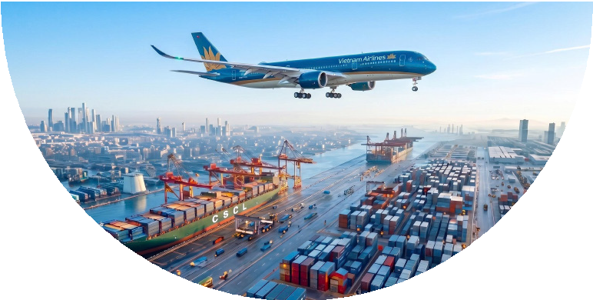
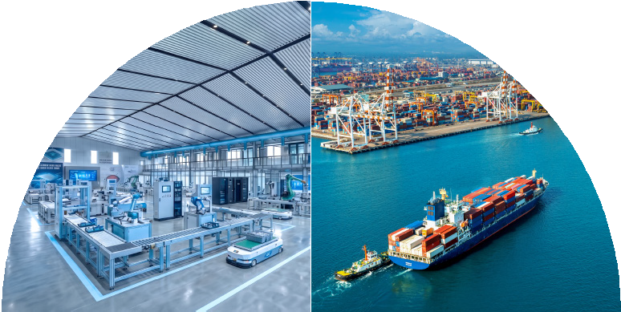




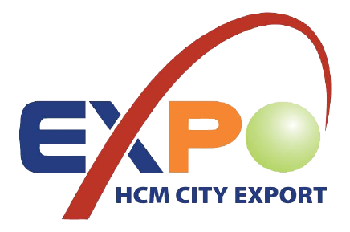
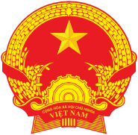
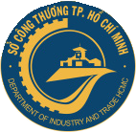
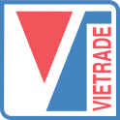

ENDORSED BY SUPPORTED BY ORGANIZED BY EXECUTED BY

MINISTRY OF INDUSTRY AND TRADE

HO CHI MINH CITY PEOPLE’S COMMITTEE

VIETNAM TRADE PROMOTION AGENCY

HO CHI MINH CITY DEPARTMENT OF INDUSTRY AND TRADE
CENTER FOR TECHNICAL SUPPORT AND SUSTAINABLE DEVELOPMENT

ON-SITE EXPORT HUB AT
VIET NAM’S INDUSTRIAL MANUFACTURING CENTER

HO CHI MINH CITY EXPORT 2026

VIETNAM’S OUTSTANDING EXPORT PRODUCTS FAIR 2026

22–24 OCTOBER 2026
WORLD TRADE CENTER BINH DUONG NEW CITY EXPO
(WTC EXPO) A19, Hung Vuong Street, Binh Duong Ward, Ho Chi Minh City, Vietnam

>750

Booths
>400

Buyers

>15.000
Visitors

KEY PRODUCT CATEGORIES





Food, Food & Agricultural Products Halal • Kosher •
Processed Food • Beverages
Textiles, Garments, Leather & Footwear
Handicrafts & Gifts Wood & Furniture
Household Appliances, Hardware & Hand Tools, Building Materials
Export Support Services Logistics • Banking • Insurance • E-commerce

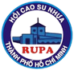
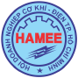
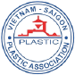
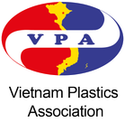

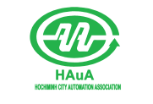


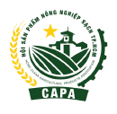
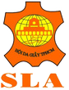

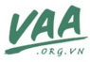
SUPPORTING PARTNERS
CONTACT INFORMATION
www.hochiminhexport.com
info@hochiminhexport.com


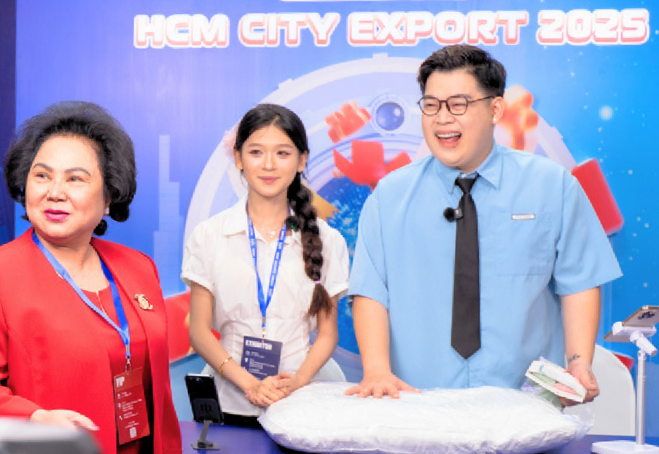
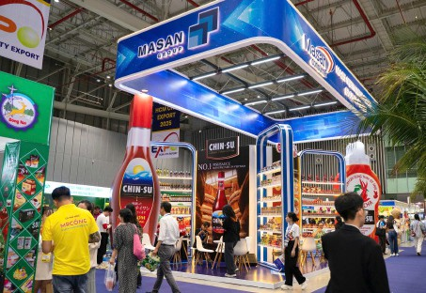




A GLOBAL BUYER NETWORK AND
ON-SITE EXPORT OPPORTUNITIES

Expected to attract over 400 buyers from the US, EU, Japan, South Korea, China, ASEAN, and other markets.
Connect with sourcing managers and merchandisers from Vietnam and around the world. Direct connections with procurement ofﬁces of leading brands and retailers such as Walmart, IKEA, Decathlon, Columbia, REI, Global Sources, and others.
Special Highlight: A Premium Buyer Connection Program, including accommodation, transportation, 1:1 business matching, and factory visits at the manufacturing hub.

DIVERSE DOMESTIC DISTRIBUTION CHANNELS
 Retail chains: Aeon, Central Retail, Lotte, Coopmart, Big C, SATRA Mart, WinMart, MM Mega Market, GS25, Genshai Mart, Farmers Market, Bách Hóa Xanh…
E-commerce platforms: Amazon, Alibaba, Shopee, Lazada, Arobid…
 Partner network: wholesalers, trading agents, importers and exporters.  Livestream sessions with KOLs/KOCs and industry forums.
 Attracting consumers to visit the fair and purchase products.

DETAILED EVENT SCHEDULE

LIVESTREAM WITH LEADING KOLs/KOCs

A SHOWCASE OF NOTABLE BOOTHS AND PAVILIONS
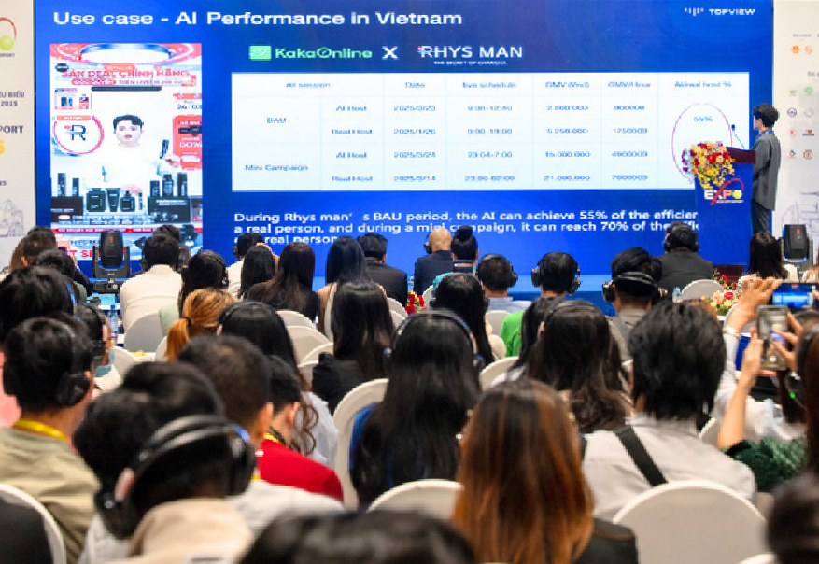
SERIES OF INDUSTRY FORUMS AND SEMINARS

21 October 2026 – Wednesday
18:00 Welcome Reception Hotel or Convention Center in Ho Chi Minh City
22 October 2026 – Thursday
09:30 - 10:30 Opening Ceremony WTC EXPO

09:00 - 21:00 • Product exhibition and showcase
- Domestic & international B2B business matching
- Export livestreams with KOLs/KOCs
WTC EXPO, factories and raw material sourcing areas

14:00 - 17:00
- Customer appreciation activities: promotions, fashion shows, culinary demonstrations, etc.
- Factory and raw material sourcing area visits
Forum: “Strengthening Partnerships towards Green Exports”

WTC EXPO

(Theme: “Resilient Supply Chains and Viet Nam’s Export Strategy in the Context of Diversiﬁcation”)
23 October 2026 – Friday

09:00 - 12:00
International Conference: “Green Manufacturing – Green Exports”
(Theme: “AI and Automation: Revolutionizing Productivity and Viet Nam’s Export Value”)
WTC EXPO

09:00 - 21:00 • Product exhibition and showcase
  - Domestic & international B2B business matching
  - Export livestreams with KOLs/KOCs
WTC EXPO, factories and raw material sourcing areas

  - Seminars, training sessions and supporting activities held in conjunction with the fair
  - Customer appreciation activities: promotions, fashion shows, culinary demonstrations, etc.
  - Factory and raw material sourcing area visits
18:00 Appreciation Reception Hotel or Convention Center in Ho Chi Minh City
24 October 2026 – Saturday

09:00 - 21:00 • Product exhibition and showcase
  - Export livestreams with KOLs/KOCs
WTC EXPO, factories and raw material sourcing areas

  - Seminars, training sessions and supporting activities held in conjunction with the fair
  - Customer appreciation activities: promotions, fashion shows, culinary demonstrations, etc.
  - Factory and raw material sourcing area visits




HIGHLIGHTS FROM PREVIOUS EDITIONS
Hundreds of major contracts signed across sectors including leather & footwear, agricultural products and food.
Businesses from Ho Chi Minh City and neighboring areas signed export MoUs worth millions of US dollars directly at the event.

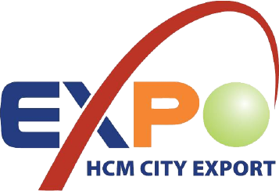
HIGHLIGHTS OF HCMC EXPORT 2026

2026

  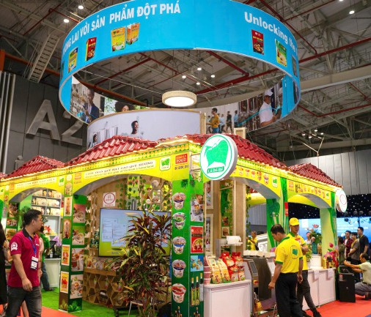  01 | THEMATIC EXHIBITION ZONES  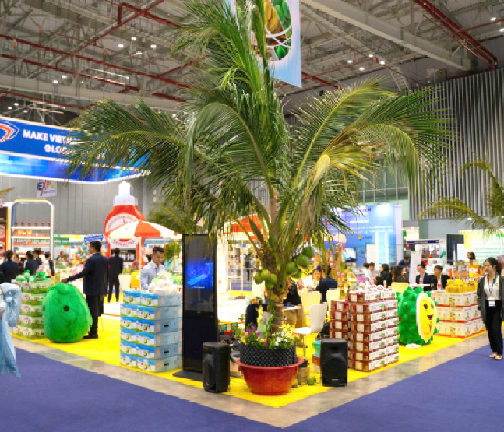  Dedicated to export products and Viet Nam’s key competitive industries.
 |  |  | 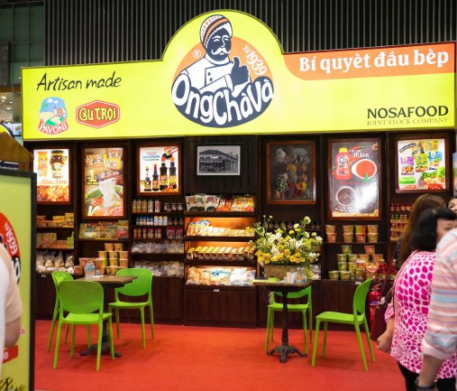 |  | 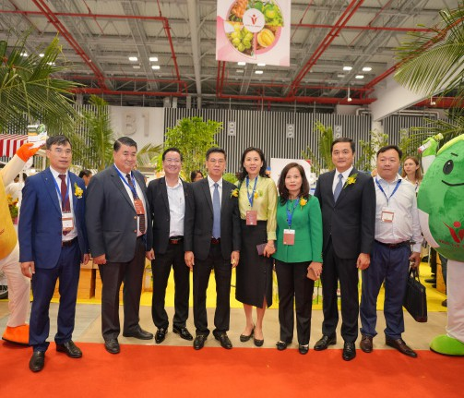
  02 | DEDICATED TO EXPORT PRODUCTS AND VIET NAM’S KEY COMPETITIVE INDUSTRIES.  Forum: “Strengthening Partnerships towards Green Exports”  Theme: “Resilient Supply Chains and Viet Nam’s Export Strategy in the Context of Diversiﬁcation”  International Conference: “Green Manufacturing – Green Exports”  Theme: “AI and Automation: Revolutionizing Productivity and Viet Nam’s Export Value”  Seminars, training sessions and supporting activities held in conjunction with the fair:  - Guidance on compliance with new export standards and requirements (CBAM, UKCA, Halal, FDA).  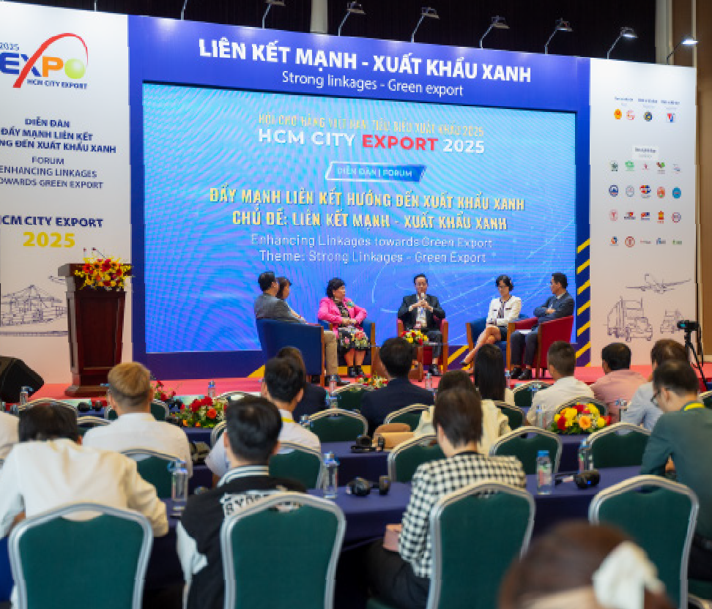  - Direct export through e-commerce platforms such as TikTok Shop and Amazon.
 |  |  | 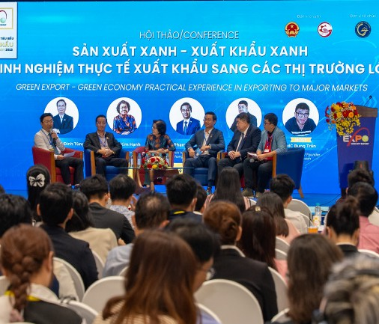 |  | 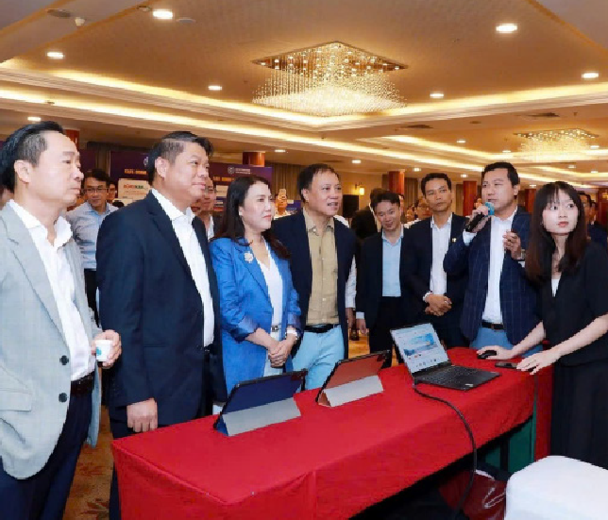 |  | 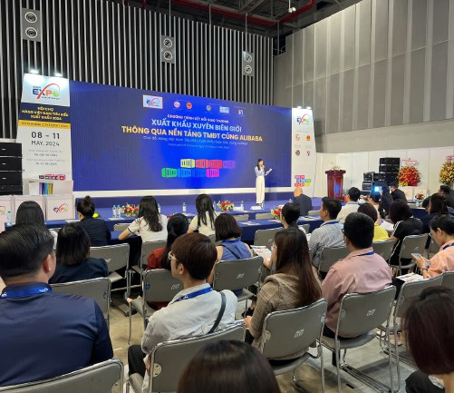
  03 | DOMESTIC & INTERNATIONAL BUSINESS MATCHING  Creating opportunities for businesses to connect directly with distribution networks, e-commerce platforms  and international buyers, while offering ﬁrst-hand exposure to manufacturing capabilities in  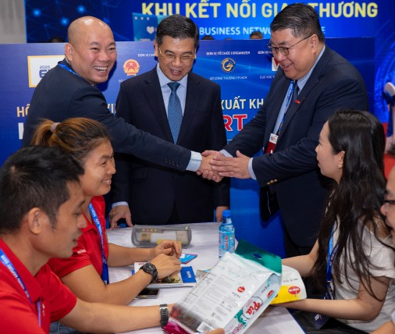  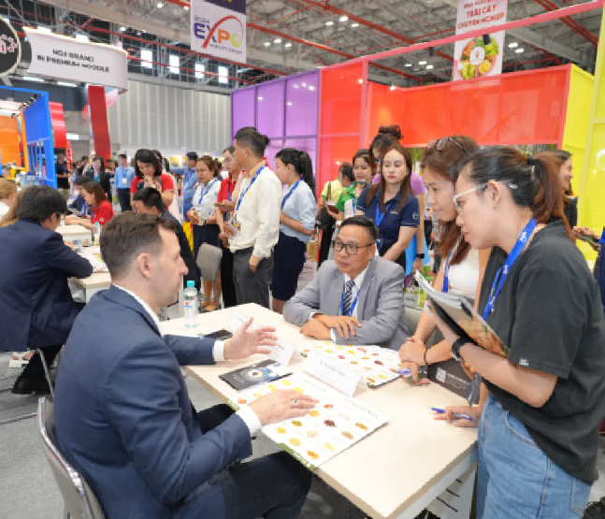  Viet Nam’s Southern Key Economic Region.
 |  |  | 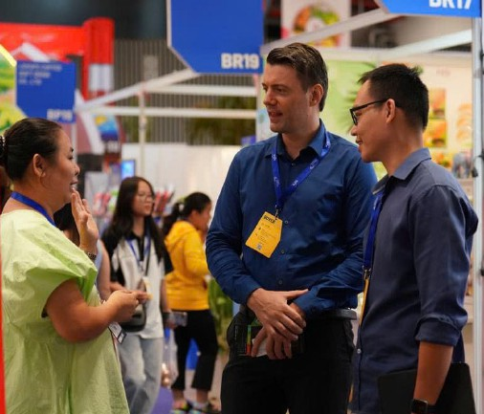 |  | 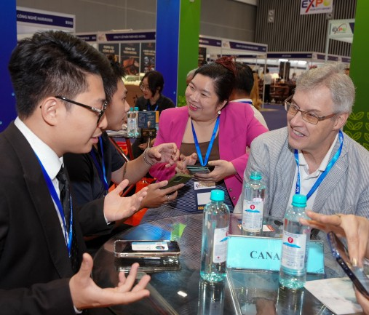

SPECIAL PARTICIPATION POLICIES

2026

BOOTH PARTICIPATION FEES
 First standard booth: 100% of the participation cost is subsidized.
 From the second standard booth onwards: VND 25,000,000 per booth.
 Raw Space Rental for Self-Built Booths: VND 2,200,000/m² (Minimum space: 18 m²) (*) First 9 m² free of charge; each additional m²: VND 2,200,000/m²

INTERNATIONAL BUYERS
 Support for accommodation, meals and transportation between the airport and WTC EXPO.
 Participation in the Welcome Reception, Appreciation Reception, factory visits and raw material sourcing area visits.

ELIGIBILITY CRITERIA FOR PARTICIPATING PRODUCTS
Products must have registered quality standards and clear traceability and origin. Products must have already been exported or demonstrate export potential.
Priority is given to products from enterprises recognized with the Ho Chi Minh City Golden Brand Award; enterprises manufacturing products listed among Ho Chi Minh City’s Key and Potential Products; and outstanding industrial and supporting-industry products of the City.

HO CHI MINH CITY – A GLOBAL GATEWAY FOR SUSTAINABLE EXPORTS FROM VIET NAM’S MANUFACTURING HUB

OUTDOOR EVENT SPACE

BOOTH LAYOUT

PARKING SPACE
 Food & Food Products  Halal & Kosher
 Circular Economy  Golden Brands
Handicrafts & Gifts
 Export Support Services  Wood Products & Furniture
 Textiles, Garments & Footwear Technology & Green Solutions

Household Appliances, Hardware & Hand Tools, and Other Export Support Services

WTC EXPO
A19 Hung Vuong Street, Binh Duong Ward, Ho Chi Minh City

TAN SON NHAT INTERNATIONAL AIRPORT
32.8 km – approximately 1 hr 24 min
Free shuttle bus service
BEN THANH MARKET
from Turtle Lake and MENAS Mall.
36.8 km – approximately 1 hr 29 min

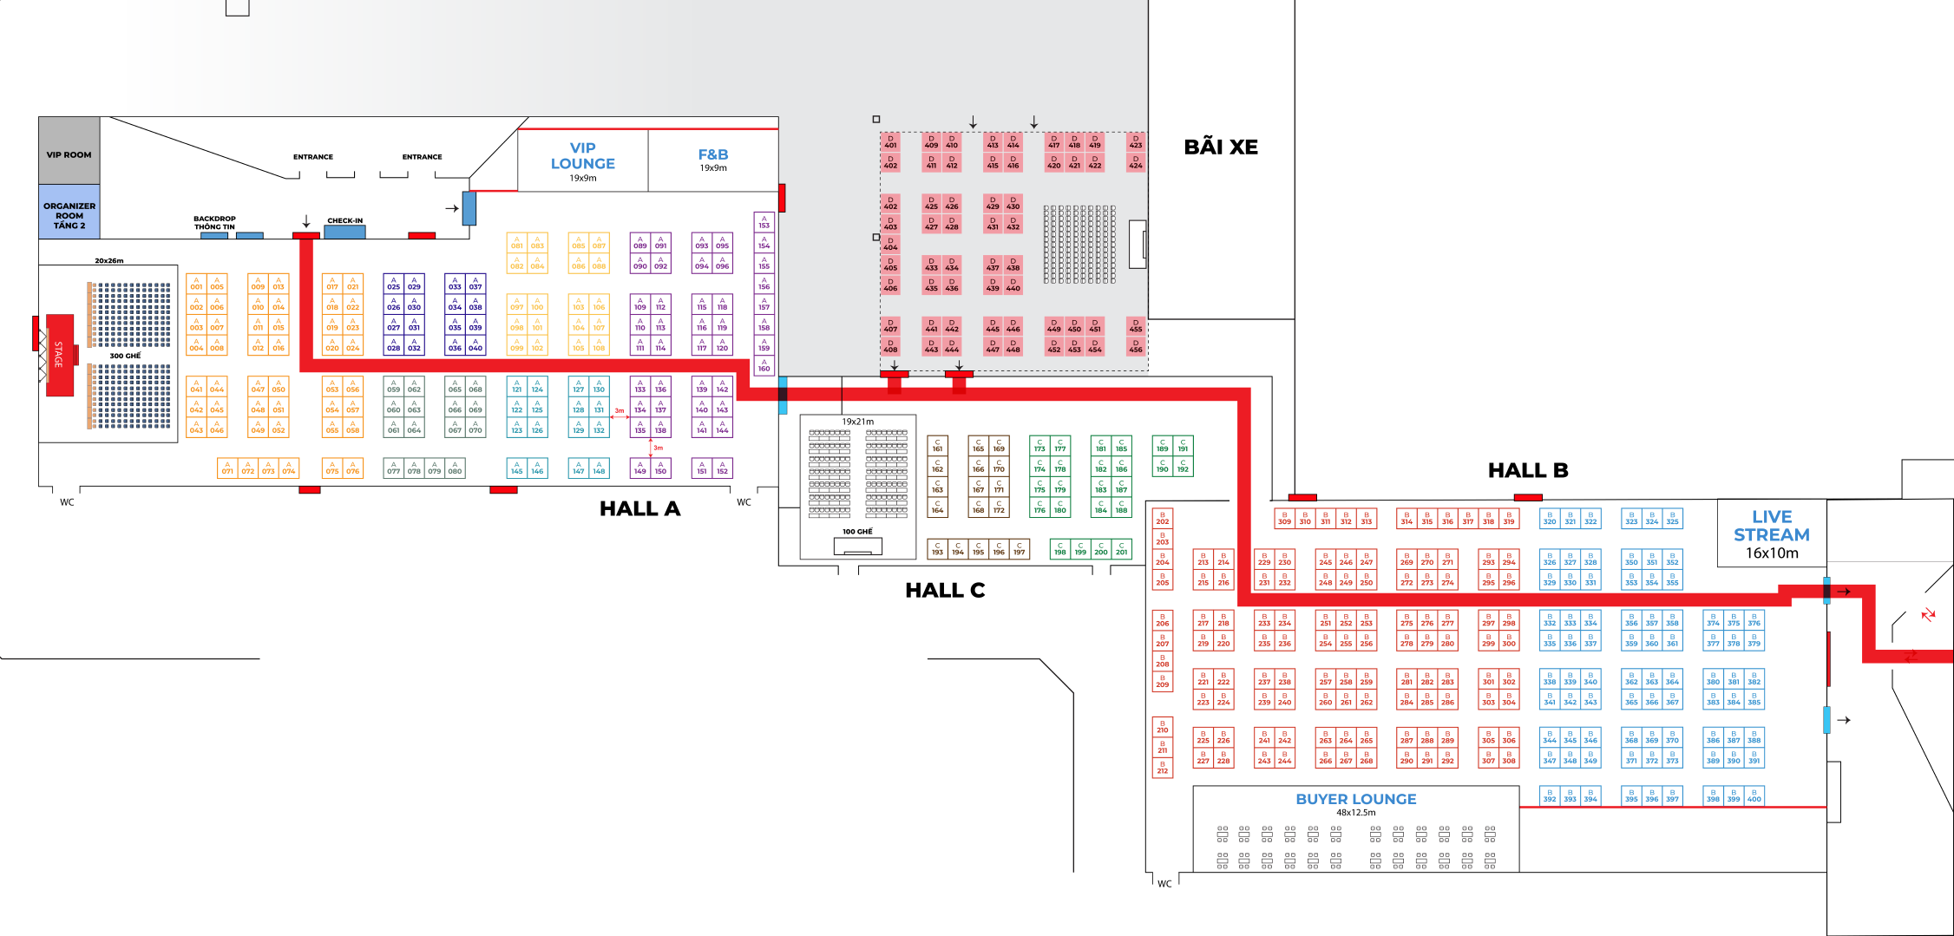

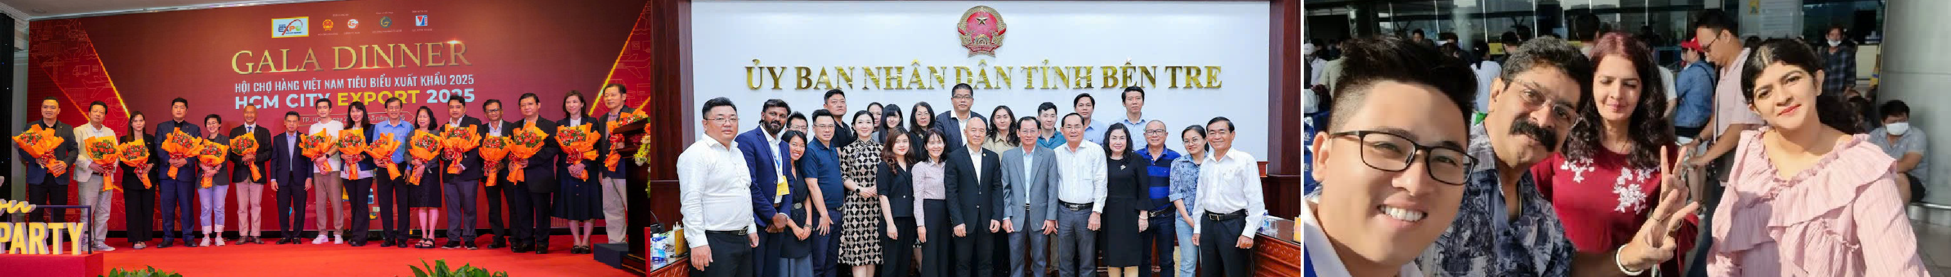





CONTACT INFORMATION

MS. PHAM THI VAN ANH
0987.254.759
ptvanh.sct@tphcm.gov.vn

MS. TRAN KIM PHUONG
0937.995.767
tkphuong.sct@tphcm.gov.vn

Scan the QR code to register

